George M. Murray Elementary School Library Remote Access Instructions
We would like to provide access of the school’s library to students for as long as possible. Students can search for books from their favourite authors or a particular topic using the School District 74 student portal. Students who do not have internet access can contact their teacher with a book title, author or subject and we will attempt to provide the materials we have. Students with internet access can look at the school catalog online, and then contact their classroom teacher or school librarian to order!
Online Library Search:
Step 1: Open the School District 74 browser on your computer or device.
It can be found at www.sd74.bc.ca
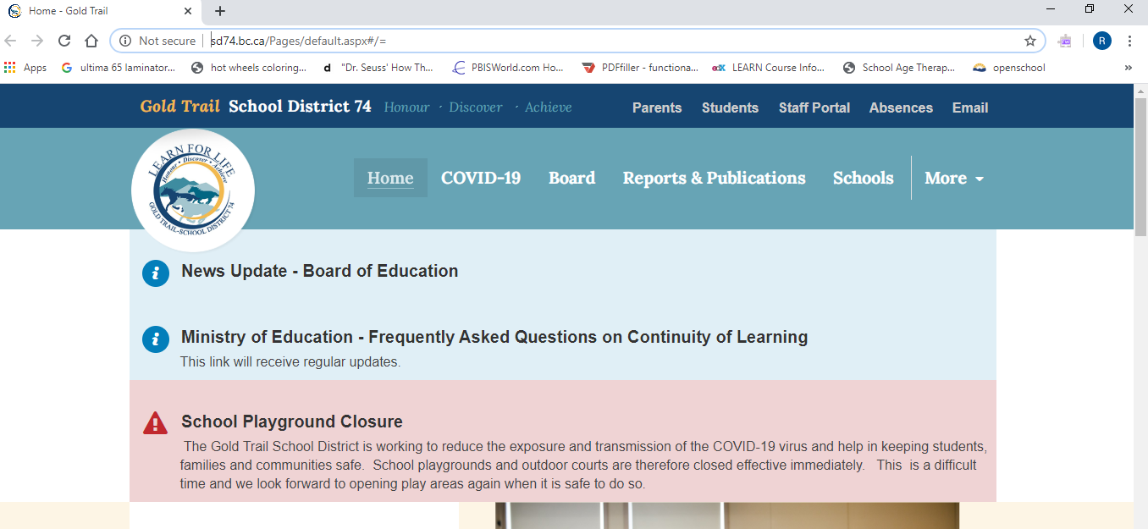
Step 2: Click on the Students option in the navy bar at the top right of the page.
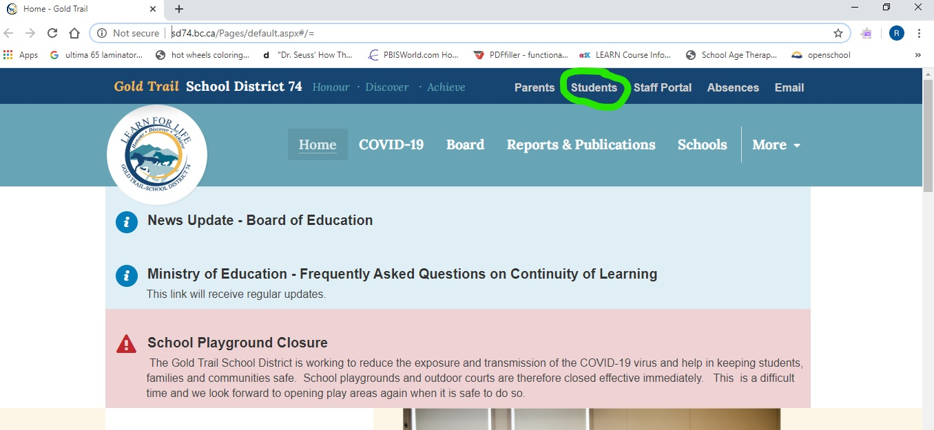
Step 3: In the Links section of the page, click Library.
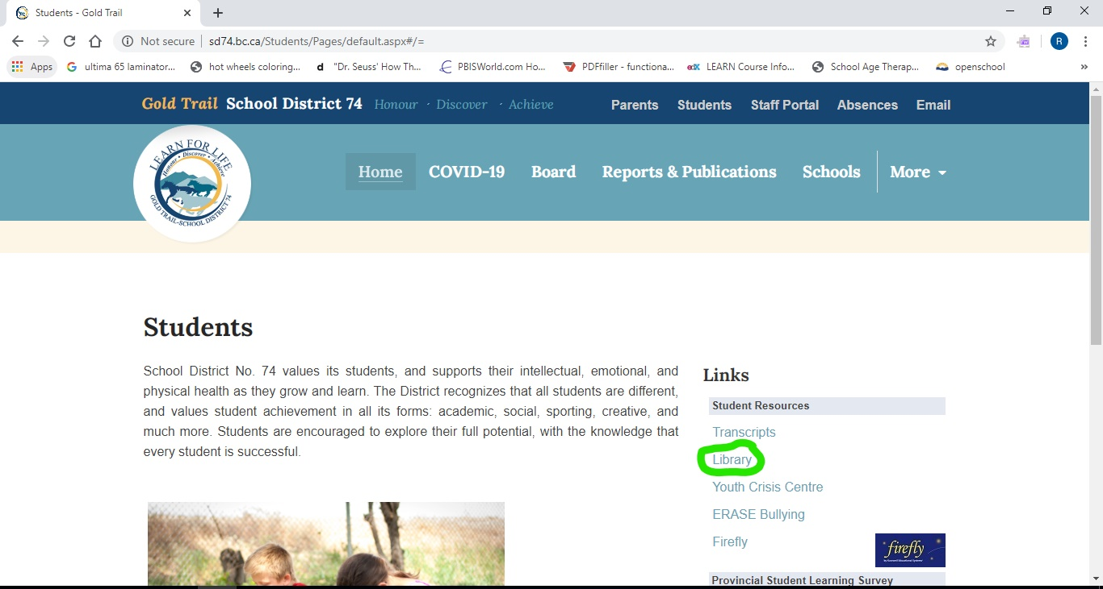
Step 4: Under Elementary Schools, click on George M. Murray Elementary School.
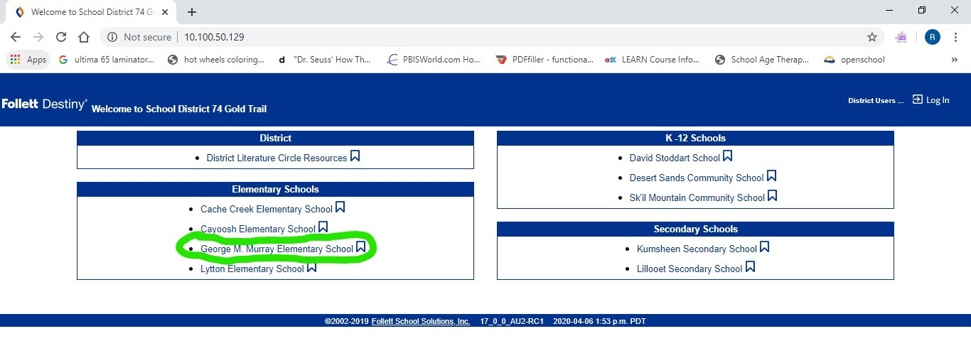
Step 5: Search in the catalog to see what is available at our school.
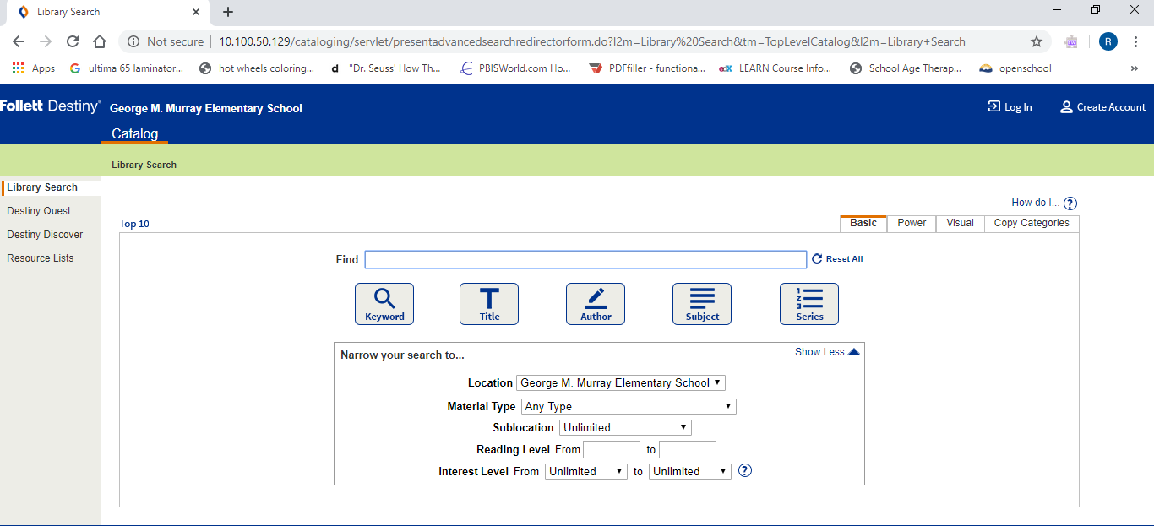
You can see if a copy is possibly available here:
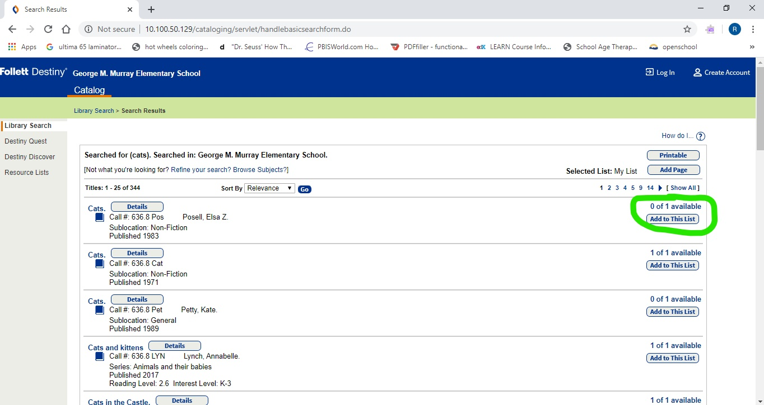
Please note that to keep contact to a minimum, we have not been signing books out through the catalog. This means that in some cases a book that the catalog says is available may in fact not be at this time. However the catalog is still a good general idea of what we have in our library.
Step 6: Contact your teacher or school librarian (Mrs. Ruiter rruiter@sd74.bc.ca) with the book title, author, and/or call number and we will do our best to get books to you!
While we would love to see the school books come back to the library eventually, it is understandable that during these stressful and unusual times that some items may get lost or damaged through home use. We would rather have students use these materials knowing that there well be some losses, than not have them available.

